**Empirical project II**

**Chipo Jaya**

**Xianghan Zhu**

**PART I:**

**Introduction** Philadelphia, one of Pennsylvania’s largest cities, presents a unique landscape for studying upward mobility. This report explores upward mobility at the Census tract level, utilizing the Opportunity Atlas—an interactive mapping tool that provides detailed socioeconomic data across the United States. By focusing on a specific Census Tract in Philadelphia, this study aims to reveal patterns of mobility and provide insights.

**Definition of Upward Mobility** Upward mobility refers to the movement of individuals from lower to higher socioeconomic positions within society. It is essential for promoting economic advancement, reducing income inequality by creating equal opportunities, and fostering innovation and growth as individuals acquire new skills and contribute to the economy (Remote, n.d.; BambooHR, n.d.). Factors that influence upward mobility include access to quality education, social support networks, and proximity to economic hubs and job markets (Remote, n.d.; Merriam-Webster, n.d.).

Research has shown that cities with lower levels of residential segregation, a larger middle class, strong family structures, greater social capital, and effective public schools tend to have higher rates of upward mobility (Chetty et al., 2014; Corcoran, 2021). In their 2018 paper, Chetty et al. also pointed out that the strongest correlates of upward mobility include segregation, income inequality, family structure, and gender disparity.

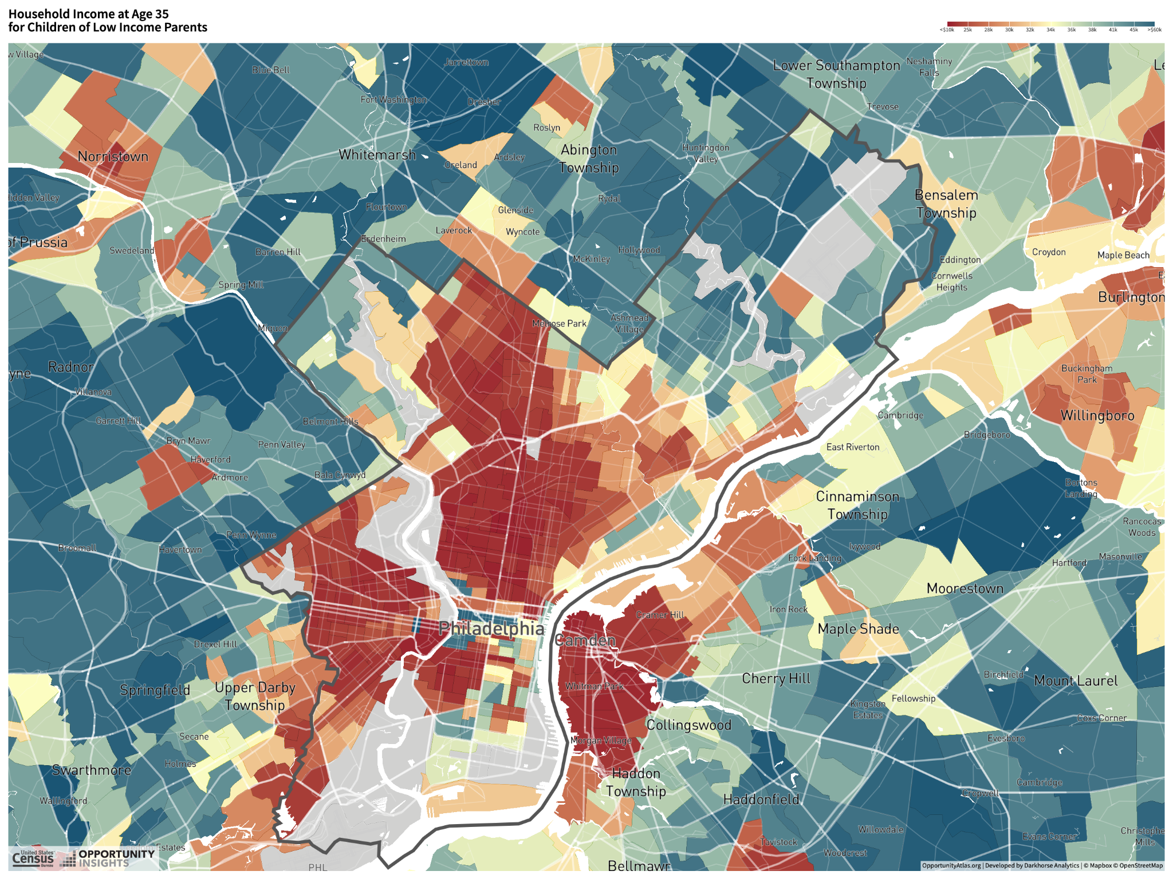

**Figure 1: City boundary of Philadelphia**

Source: [www.opportunityatlas.org/](http://www.opportunityatlas.org/)

Philadelphia was once the capital of the United States, but over time, the city has experienced economic decline due to competition from New York to the north, Washington, D.C., to the south, and the relocation of the steel industry from the Great Lakes region. This shift led to widespread unemployment among former ironworkers. Nonetheless, Philadelphia has evolved into a prominent commercial center, drawing individuals to work in business, with many achieving significant wealth. As a result, Philadelphia has pronounced disparities in household income and a diverse ethnic composition. North Philadelphia generally consists of lower-income households with limited upward mobility, whereas South Philadelphia is more economically and demographically varied. Thus, within Philadelphia, areas range from highly integrated to economically disadvantaged.

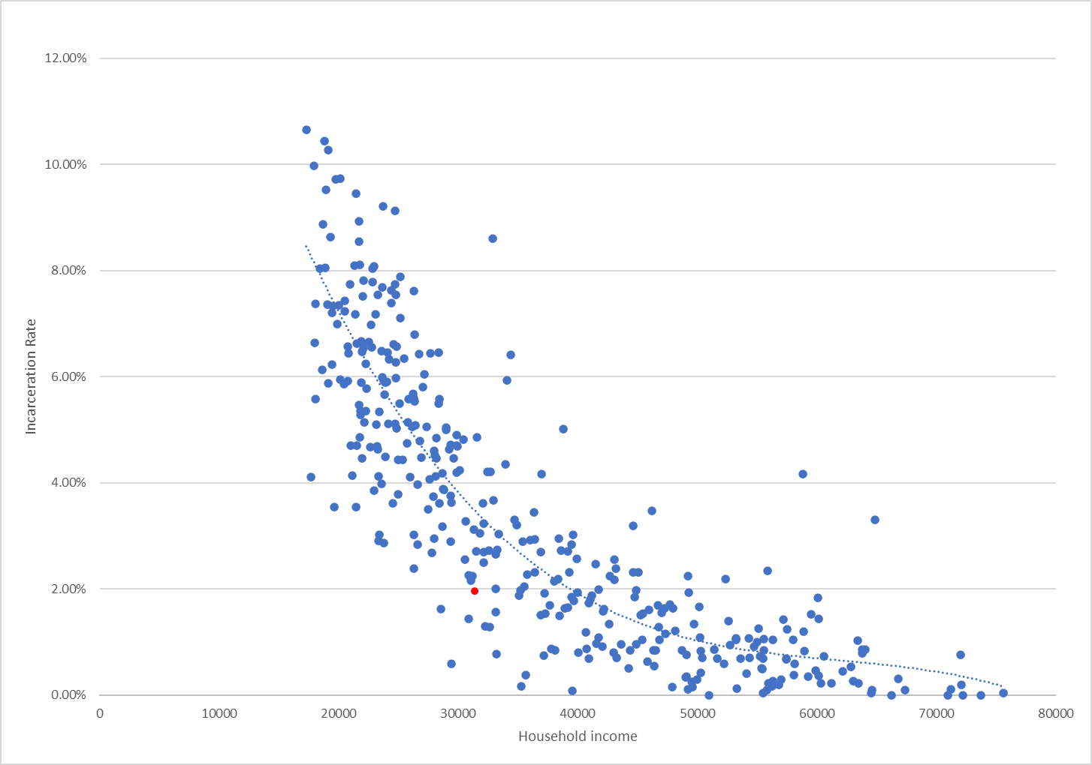

**Chart 1: Scatterplot of household income and incarceration rate in all of Philadelphia’s tracts**

We first create a scatterplot between household income and incarceration rate of all tracts in Philadelphia. We put household income on the x-axis as we think it is an independent variable, and the incarceration rate is dependent on it. We can clearly see that there is a negative correlation between household income and incarceration rate, where the higher the household income is, the lower the incarceration rate is. This appeals to intuitive sense and is validated by statistical calculations. Our tract of interest is labeled with a red dot.

However, we tried to use linear regression, yet we think that does not capture the real situation between these two variables. When looking at the details of the graph, we can see that the rate of change between these two variables is different before and after a certain household income level. When the household income is very low, a slight increase in it will lead to a greater decrease in the incarceration rate. However, beyond certain household income, the change will lead to a smaller decrease in the incarceration rate. This suggests that people tend not to perform illegal actions when they have made enough money. As a result, we instead use polynomial correlation with an order of 3, which better captures the characteristics of the data of all tracts.

**The Chosen Census Tract** This analysis centers on Census tract 42101003702 in South Philadelphia. This tract was selected for its similarities to our hometowns—Shanghai, China, and Harare, Zimbabwe. Although the demographics are more diverse in this tract than in our hometowns, all three regions share a reliance on steel production as a foundational industry, followed by similar transformations over time. The racial composition of this Census tract includes Asian, White, and Black populations.

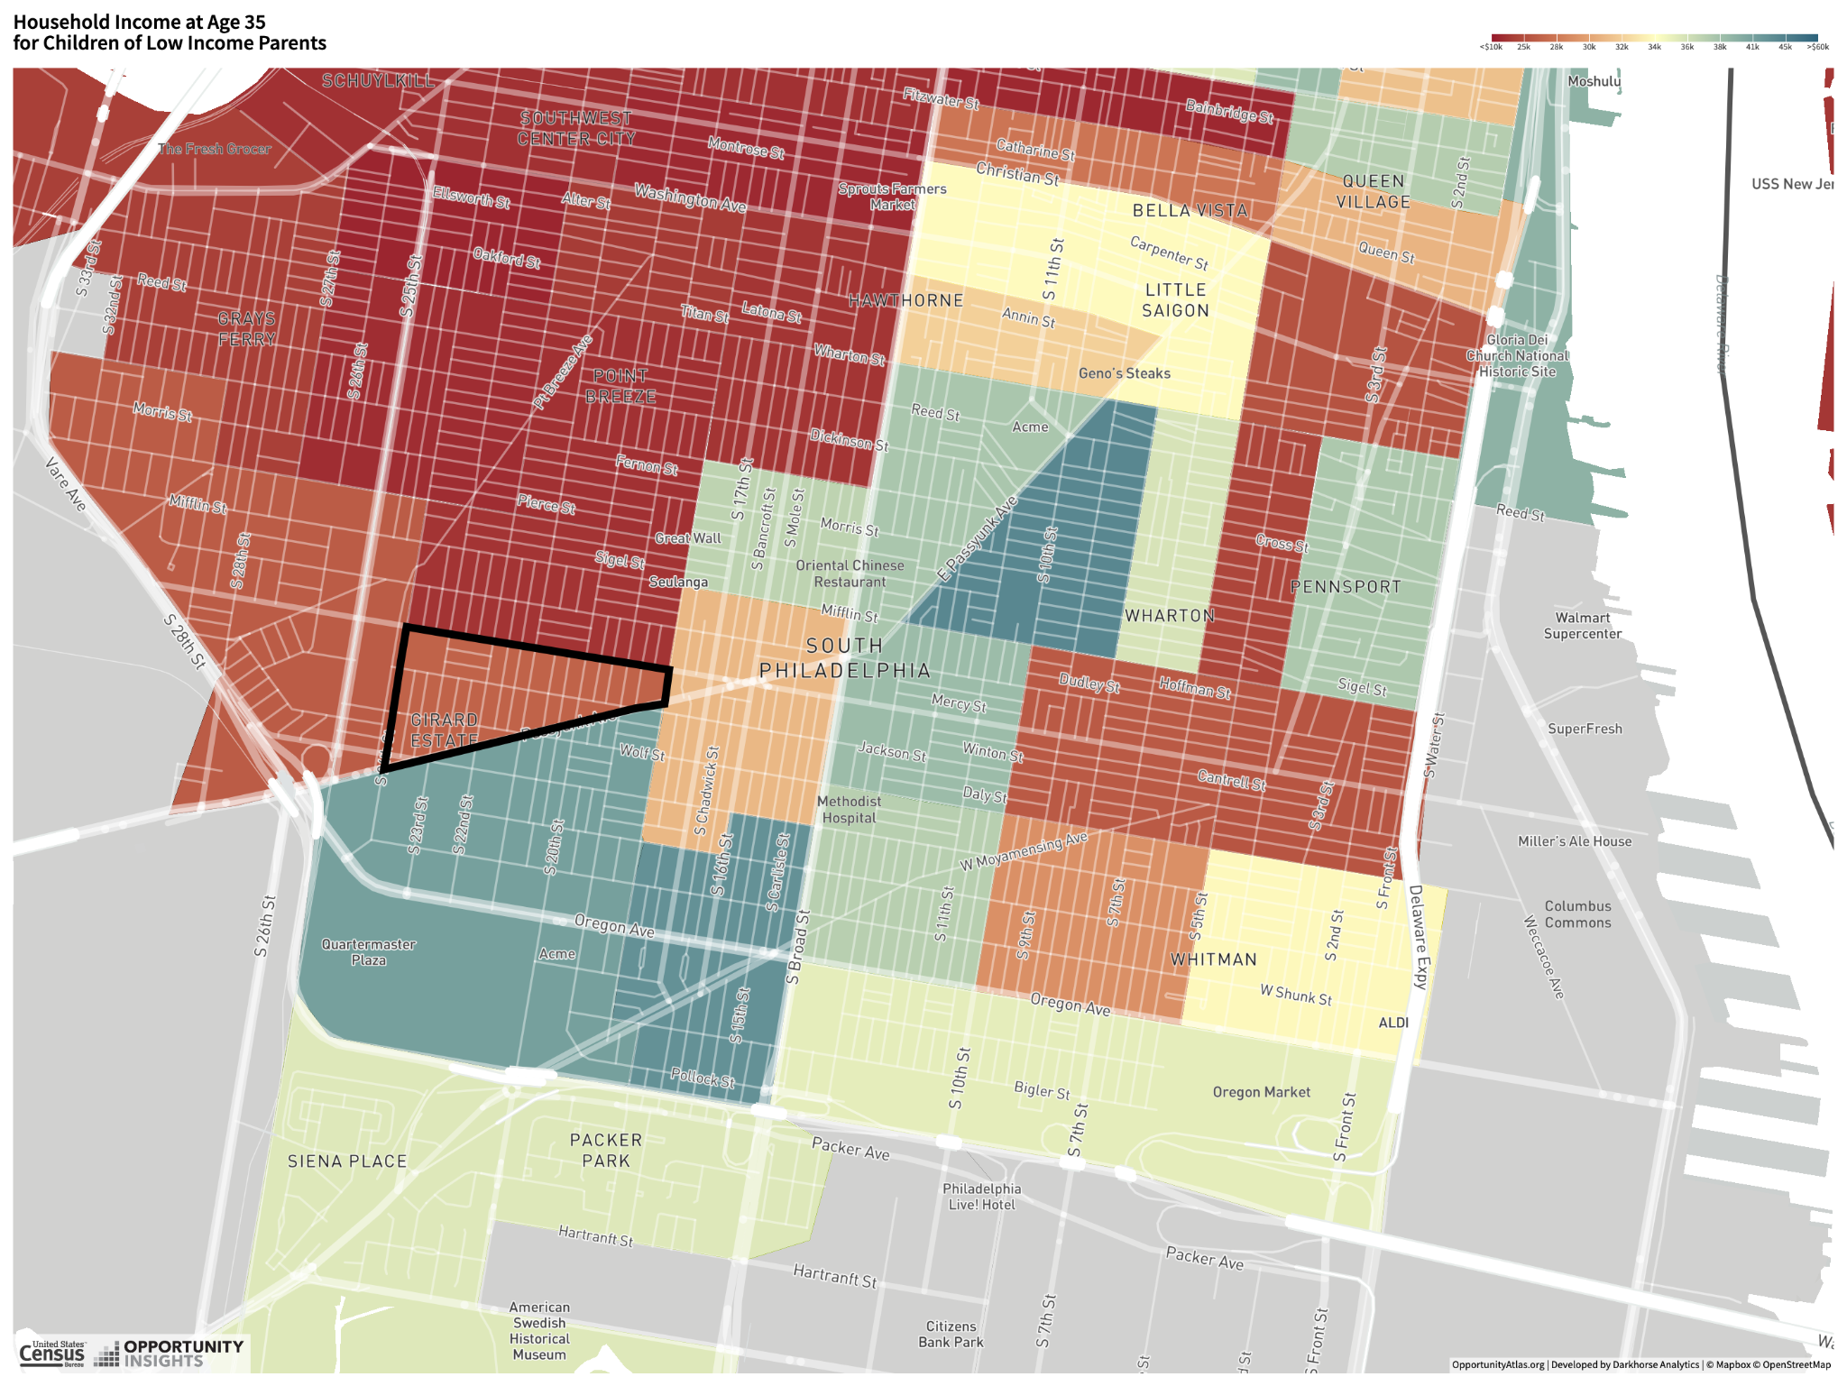

**Figure 2: Household Income of Children Raised by Low-Income Parents (Tract 42101003702)**

Source: [www.opportunityatlas.org/](http://www.opportunityatlas.org/)

Figure 2 illustrates household income at age 35 for children born to low-income parents across various Census tracts in Philadelphia. The color variations highlight income disparities, reflecting the neighborhoods in which these children were raised. The differences in color represent variations in economic mobility by neighborhood: darker red tracts signify areas of lower economic mobility, where children from low-income households tend to have average household incomes below $30,000 in adulthood.

**Upward mobility factors**

**Segregation.** From the map, we can see that Chetty et al. 2018 highlighted that segregation is one of the key correlates of upward mobility. By examining the racial composition within Philadelphia and outside of it, it is clear that the rich tracts overlap greatly with where white people live. White people generally live just outside of Philadelphia and commute to work in the downtown area of Philadelphia, while the region in between is crowded with tracts that are extremely poor and have a much higher incarceration rate. This indicates that segregation is a clear reason or outcome for the difference in upward mobility. We also looked up the real estate prices among these regions, and the difference is too significant to be afforded by lower-income households. Thus, before racial segregation, income segregation is even more obvious in Philadelphia.

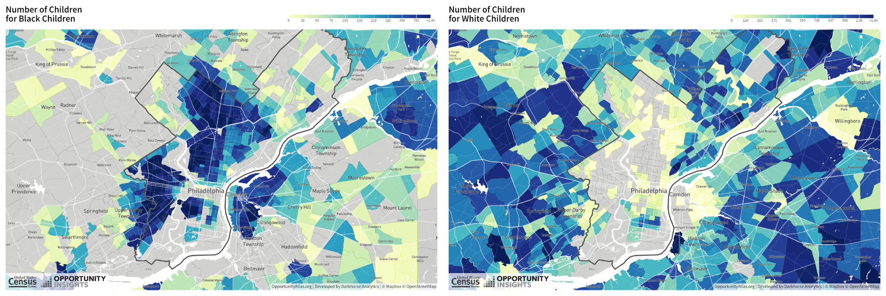

**Figure 3: Children number between white black people (left) and white people (right)**

**Family Structure.** It is clear from these two figures that white people and black people tend to have the same number of children in this region, which does not appeal to intuition and there is an inverse relationship between the number of children and household income. The white people in this region are rich despite the number of children, and the black people are poor despite the number of children. This further supports us that there exists segregation in race and income in Philadelphia.

In particular, Asian residents in this region perform significantly better than other ethnic groups. This trend appears tied to the presence of a school in the area and the high-value Asian communities place on education. Many Asian families choose to live near schools to support each other in childcare and provide social connections for their children. Although the influence of a school on household income may not seem immediately clear, broader observations show that tracts with schools tend to have higher incomes among Asian residents. This pattern likely results from an aggregation effect: higher-income Asian families prefer these neighborhoods and collectively send their children to the same school, rather than the tract itself driving higher income levels. In other words, higher household incomes among Asians in these tracts are more of an outcome than a cause. Additionally, close networking among parents in these communities fosters frequent information sharing and mutual referrals, enhancing job opportunities and contributing to rising household incomes.

Asian households in this area are in the 91st income percentile, compared to 29% for Black households and 21% for White households. The average incarceration rate is 2.7%, with rates for Asians below 1%, Whites at 1.7%, and Blacks at 3.1%.

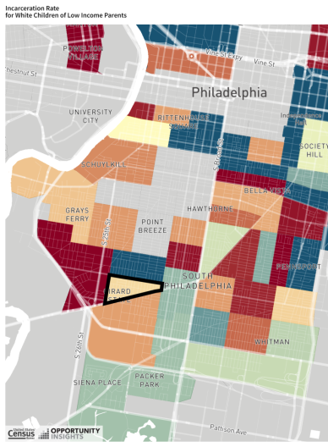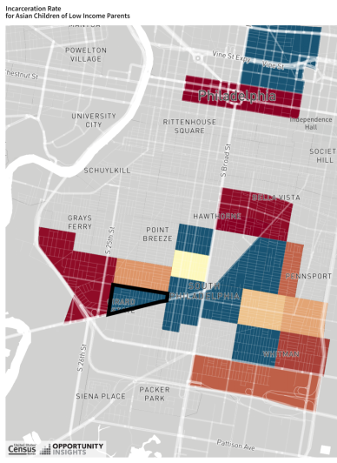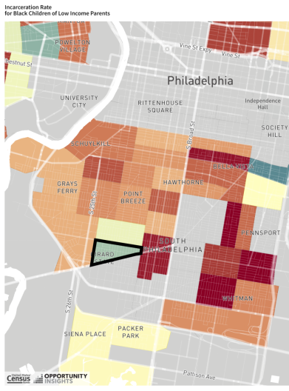

**Figure 4: Incarceration Rates by Race**

Figure 3 illustrates the variation in incarceration rates among different racial groups, with Asians exhibiting the lowest rate. A negative correlation is evident between household income and incarceration rate, where higher household incomes align with lower incarceration rates. Examining the data more closely, the tract provides specific incarceration rates for White and Black males, while data for all females and Asian males is only available at the city level. The incarceration rate for females is significantly lower than for males, underscoring that the majority of incarcerated individuals are male. Breaking down the rates by race, the incarceration rate for Black males is 8.3%, compared to 3.5% for White males. Among Asians in Philadelphia, the overall incarceration rate of males is 0.92%, with Asian females exhibiting the lowest rate at under 0.1%.

|  |  |  |
| --- | --- | --- |
|  | Household Income | Incarceration rates |
| Neighboring Tract 3600 | $29,384.00 | 4.72% |
| Neighboring Tract 3701 | $22,982.00 | 3.86% |
| **Our Tract 3702** | **$31,445.00** | **1.95%** |
| Neighboring Tract 3800 | $50,141.00 | 1.66% |
| Neighboring Tract 3901 | $37,676.00 | 1.70% |

**Table 1: Income-incarceration comparison with surrounding tracts**

|  |  |  |  |  |  |  |
| --- | --- | --- | --- | --- | --- | --- |
| Race | White | | Black | | **Asian** | |
| Gender | males | females | males | females | **males** | **females** |
| Household Income | 32K | 51K | 18K | 24K | 56K | |
| Individual Income | 27K | 35K | 13K | 22K | 33K | |
| Incarceration Rates | 1.2% | *0.17%* | 8.3% | *0.48%* | *0.85%* | *<0.1%* |

**Table 2: Intersectional Analysis Table[1]**

From Table 2, we can see that in this specific tract, females earn more than males, indicating that females have a higher desire to move upward and live in a better neighborhood, while males are lazy and reluctant to move upward and more likely to stay where they have already been.

Focusing on our tract and surrounding areas, household income, and crime vary considerably among these tracts. From Table 1. We see that our tract (3702) is in a relatively favorable position compared to most of its neighbors. It has the second-highest household income of $31,445 and a middle-range incarceration rate of 1.95% compared to its neighbors. The incarceration rate is lower than in three of the five tracts, including two with lower incomes.

Tract 3800, located below our tract, has the highest household income ($50,141) which is more than double that of tract 3801 with the lowest income of the 5. Incarceration rates range from 1.66% to 4.72%, a nearly threefold difference. From these figures, it is evident that there are significant socioeconomic disparities among the neighboring tracts which could harm overall community dynamics and opportunities for upward mobility.

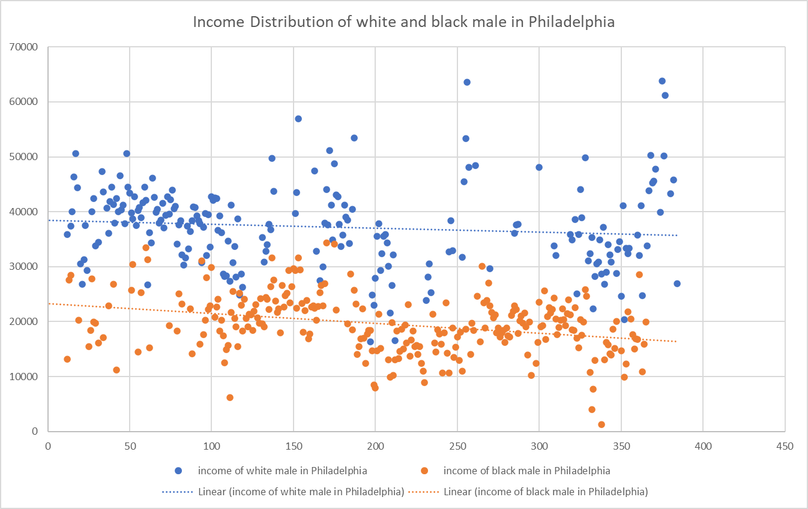

**Chart 2: Income Distribution of white and black male in Philadelphia**

From this chart, we can see that white males in Philadelphia earn generally more than Black males. The numbers on the x-axis indicate the tract count and are not ordered by any means at all. Thus, the correlation line does not have any meaning other than showing the average income distribution.

To clarify the differences between children who grew up in families with different income levels, we do descriptive statistical analysis. Here are the summary statistics of household income for children with parents at the 25th, 75th, and 100th percentile at the tract, state, and national levels.

For a more accurate representation of the overall population characteristics, we calculate weighted mean, standard deviation, min, and max for Pennsylvania and the United States but not for the tract.

|  |  |  |  |  |  |  |
| --- | --- | --- | --- | --- | --- | --- |
|  | Obs | Mean | Std. Dev | Min | Max | Weights |
| Tract 42101003702 |  |  |  |  |  |  |
| *kfr_p~25* | 1 | 27020.47 | . | 27020.47 | 27020.47 | . |
| *kfr_p~75* | 1 | 45220.38 | . | 45220.38 | 45220.38 | . |
| *kfr_p~100* | 1 | 64129.5 | . | 64129.5 | 64129.5 | . |
| Pennsylvania |  |  |  |  |  |  |
| *kfr_p~25* | 3177 | 36681.01 | 8026.122 | 14206.22 | 73410.77 | 2919711 |
| *kfr_p~75* | 3177 | 56049.1 | 9465.568 | 17613.4 | 92102.54 | 2919711 |
| *kfr_p~100* | 3175 | 77045.79 | 16748.05 | 17435.61 | 980579 | 2919133 |
| United States |  |  |  |  |  |  |
| *kfr_p~25* | 71923 | 34311.68 | 7899.586 | 0 | 105732.4 | 72229071 |
| *kfr_p~75* | 71925 | 51284.03 | 9326.094 | 156.9863 | 137454 | 72229817 |
| *kfr_p~100* | 71886 | 69218.15 | 16362.81 | 0 | 980579 | 72215136 |

**Table 3: Summary Statistics[2]**

**Upward Mobility Analysis:**

From Table 1, the track we chose at the 25th percentile performs worse than its counterpart at the state and national level. The tract's average household income for these children is $27,020.47, which is significantly below the state-level weighted average of $36,681.01 and the national weighted average of $34,311.68.[3] We calculated weighted summary statistics because This means that children from lower-income households in our tract are unlikely to achieve upward mobility if they continue to live in this tract. They tend to face greater challenges in achieving upward mobility compared to their peers in other parts of Pennsylvania and the nation. To move upward, one is recommended to leave the tract and live in a tract that outperforms the state’s mean.

The standard deviation for the 25th percentile in Pennsylvania is larger than that of the state, yet they are still very similar to each other and may not have statistical significance. The means are close to each other as well. This indicates that the state of Pennsylvania is similar to the average upward mobility of the entire country, making Pennsylvania a good sample state to be chosen from. Based on this comparison, the tract that we chose did not make up to the average of the state and is about one standard deviation below the mean. This tells us that the upward mobility of our tract is at around 34% of the country.

**Downward Mobility Analysis:**

On the other hand, children from the tract and in the 75th percentile, show less downward mobility compared to children in the entire state and national. The average income for the child in the tract is $45,220.38 while the state average is $56,049.10 and the national average is $51,284.03. This indicates that children from higher-income families in this tract tend to maintain their economic status better than the others in the state and nation. At the 100th percentile, the tract's average income of $64,129.50 is lower than both Pennsylvania state's average of $77,045.79 and the national average of $69,218.15, indicating some downward mobility for the highest-income families, slightly less than the state and national trends.

For individuals in Census Tract 42101003702 who started in higher income brackets (75th and 100th percentiles), the average income is $45,220.38 and $64,129.50, respectively. These values are significantly lower than the corresponding averages at both the state and national levels, suggesting that individuals who began in higher income brackets in this tract are more likely to experience downward mobility—a drop to lower income levels relative to their starting point.

In Pennsylvania, the 75th percentile mean income is $56,049.10, and the 100th percentile is $77,045.79. These are higher than the tract-level averages. The gap between the tract and state averages at the 75th and 100th percentiles indicates that high-income individuals in this tract are more vulnerable to losing economic ground compared to their peers across Pennsylvania.

Nationally, the 75th percentile mean income is $51,284.03, and the 100th percentile is $69,218.15. These averages are also higher than those in Tract 42101003702. This comparison further emphasizes the trend of downward mobility for individuals in the higher-income brackets within this tract, as they earn less than their national counterparts in similar starting percentiles.

The downward mobility of children in Census Tract 42101003702 is evident as their average household incomes are lower than both the state and national averages at the 75th and 100th percentiles. This means that children who come from relatively high-income families in this tract tend to earn less as adults than their counterparts in other parts of Pennsylvania and the U.S. overall. Compared to the state and national averages, children from higher-income backgrounds in this tract are more likely to experience downward mobility, showing a greater tendency to earn less than their parents did.

The higher standard deviation in Pennsylvania suggests more pronounced variability in economic outcomes across tracts in the state. This could mean that while some tracts in Pennsylvania may allow high-income children to maintain their economic status, others exhibit stronger patterns of downward mobility. This disparity points to possible structural factors in Pennsylvania, such as differences in job opportunities, education, or economic conditions, that lead to greater downward mobility in certain areas.

**PART II:**

**Q1. Using linear regression, estimate the relationship between outcomes of children at the 25th and 75th percentile for the Census tracts in your home county. Generate a scatter plot to visualize this regression. Do areas where children from low-income families do well generally have better outcomes for those from high-income families, too?**

We conducted a linear regression to explore relationships between outcomes for children at different percentiles within Philadelphia County.

The results regression shows a strong, positive relationship between incomes at the 25th and 75th percentiles in the specified area of Pennsylvania, with higher incomes at the lower end associated with even higher incomes at the upper end of the distribution.

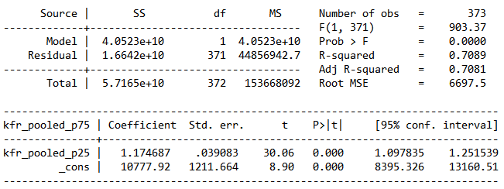

**Table 4: Linear Regression results**

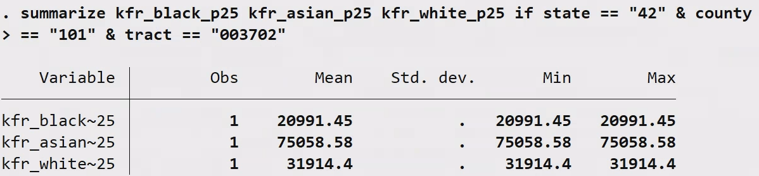

**Table 5: The household income at the 25 percentile for different races at tract level**

In Tract 42101003702, children from both low-income and high-income families have worse outcomes compared to their counterparts at the state and national levels. This implies that economic mobility is generally constrained across income levels in this tract. The data from this tract suggests that areas, where children from low-income families do poorly (limited upward mobility), are also places where children from high-income families experience downward mobility. Thus, in this case, there does not appear to be a positive correlation between outcomes for low-income and high-income families—poor outcomes for one group do not correlate with better outcomes for the other.

Based on this single tract, it appears that poor outcomes for low-income children correlate with poor outcomes for high-income children, which may be due to structural factors within the area that impacts everyone, such as limited access to quality education, fewer job opportunities, or economic stagnation.

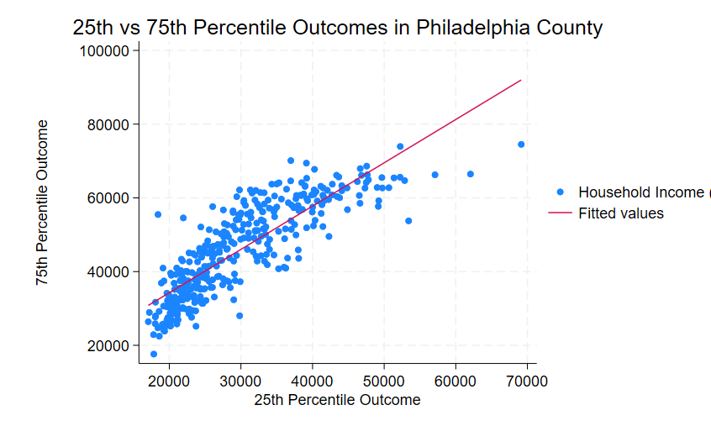

**Figure 5: scatterplot of household income at the 25 and 75 percentile**

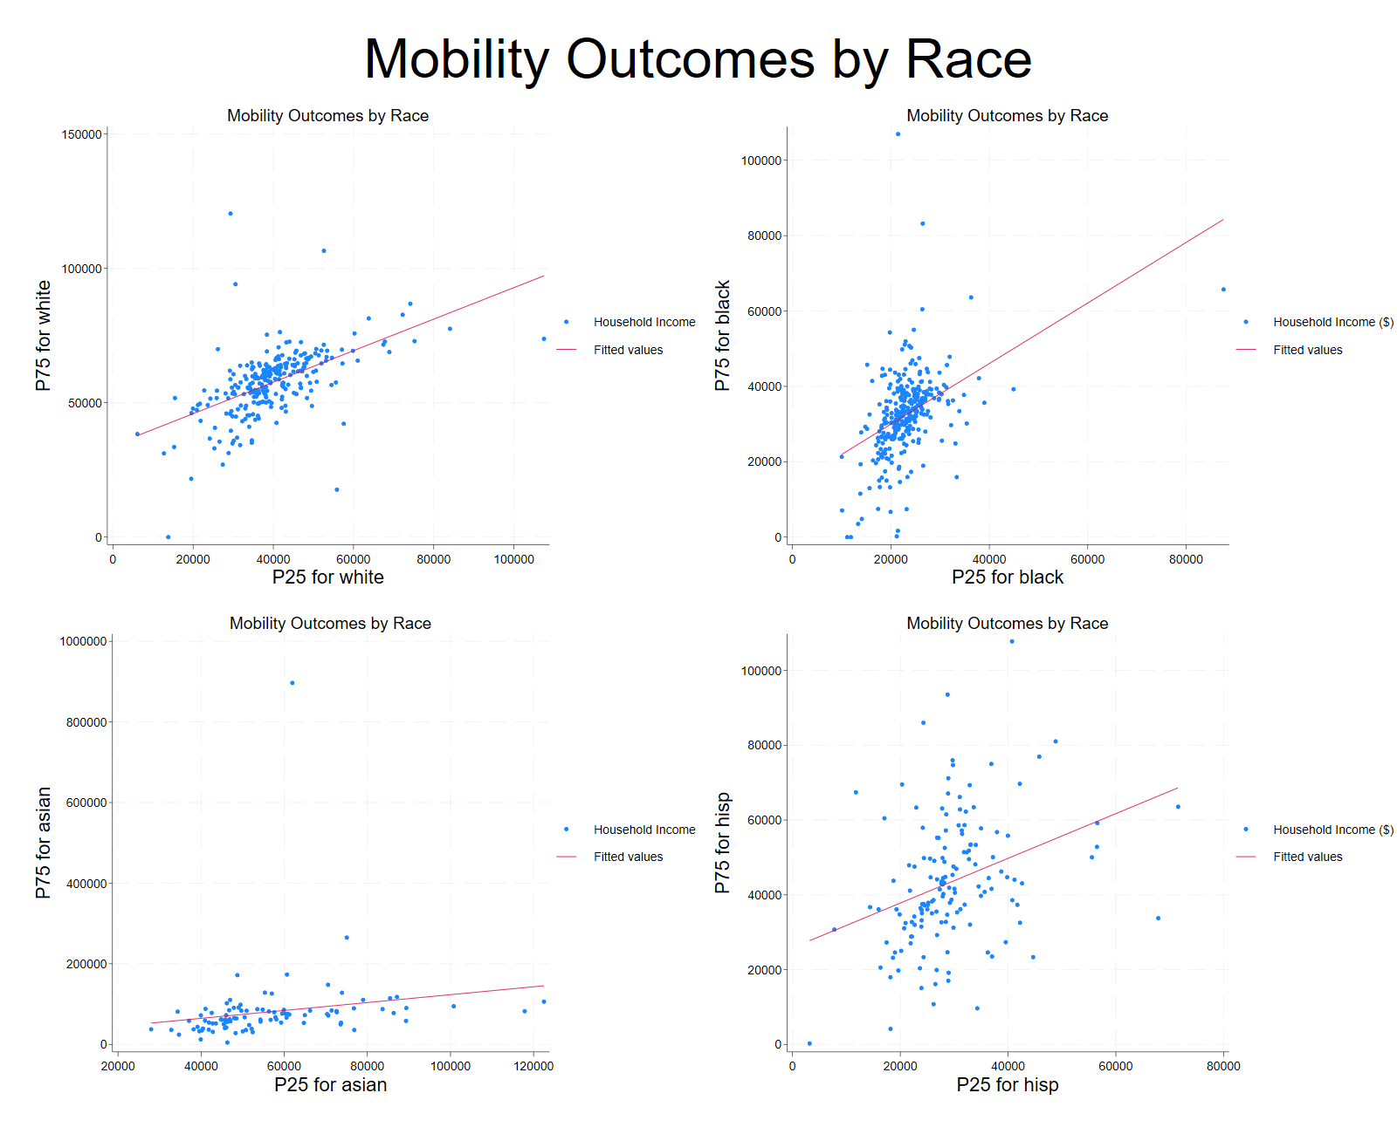

**Figure 6: Mobility outcomes by race**

From these scatterplots, we can see that all races demonstrate a correlation between 25 and 75 percentile household income, whereas Asian people have a mild positive correlation, white people have a moderately positive one, and black people have a strongly positive one. It is worth noticing that Black people have clustered performance around 30,000, which means that the overall household income in that tract is more homogeneous.

**Part III:**

Introduction to the Covariate Analysis

In our analysis of factors influencing upward mobility in Philadelphia's Census tracts, we have selected key explanatory variables based on their relevance, consistency with existing literature, and availability in our merged dataset from the Opportunity Atlas. These variables are:

1. Median household income
2. Poverty (Income inequality - Gini index)
3. Single-parent household share
4. Fraction of adults with a college degree

Our selection is aligned closely with the rationale of Chetty et al. (2018), who identified these factors as strong correlates of upward mobility. Our explanatory variables encompass multiple dimensions of neighborhood characteristics:

1. Economic conditions (median household income and income inequality)
2. Educational attainment (fraction of college-educated adults)
3. Family structure (single-parent household share)

This approach allows us to capture various aspects that potentially influence economic mobility, aligning with the Opportunity Atlas insight and offering comparability with other studies.

To analyze the relationship between these variables and upward mobility, we propose the following linear regression model:

+ + + + )

Where:

1. $Upward_Mobility$: Measured as the mean household income rank for children whose parents were at the 25th percentile of the national income distribution
2. $β_{0}$: Intercept
3. $β_{1}$- $β_{5}$: Coefficients for each independent variable
4. *ε*: Error term

By focusing on these variables, we aim to provide a comprehensive analysis of the factors contributing to upward mobility in Philadelphia's neighborhoods, potentially informing targeted policy interventions to improve economic opportunities and outcomes.

Distribution and Correlation Analysis

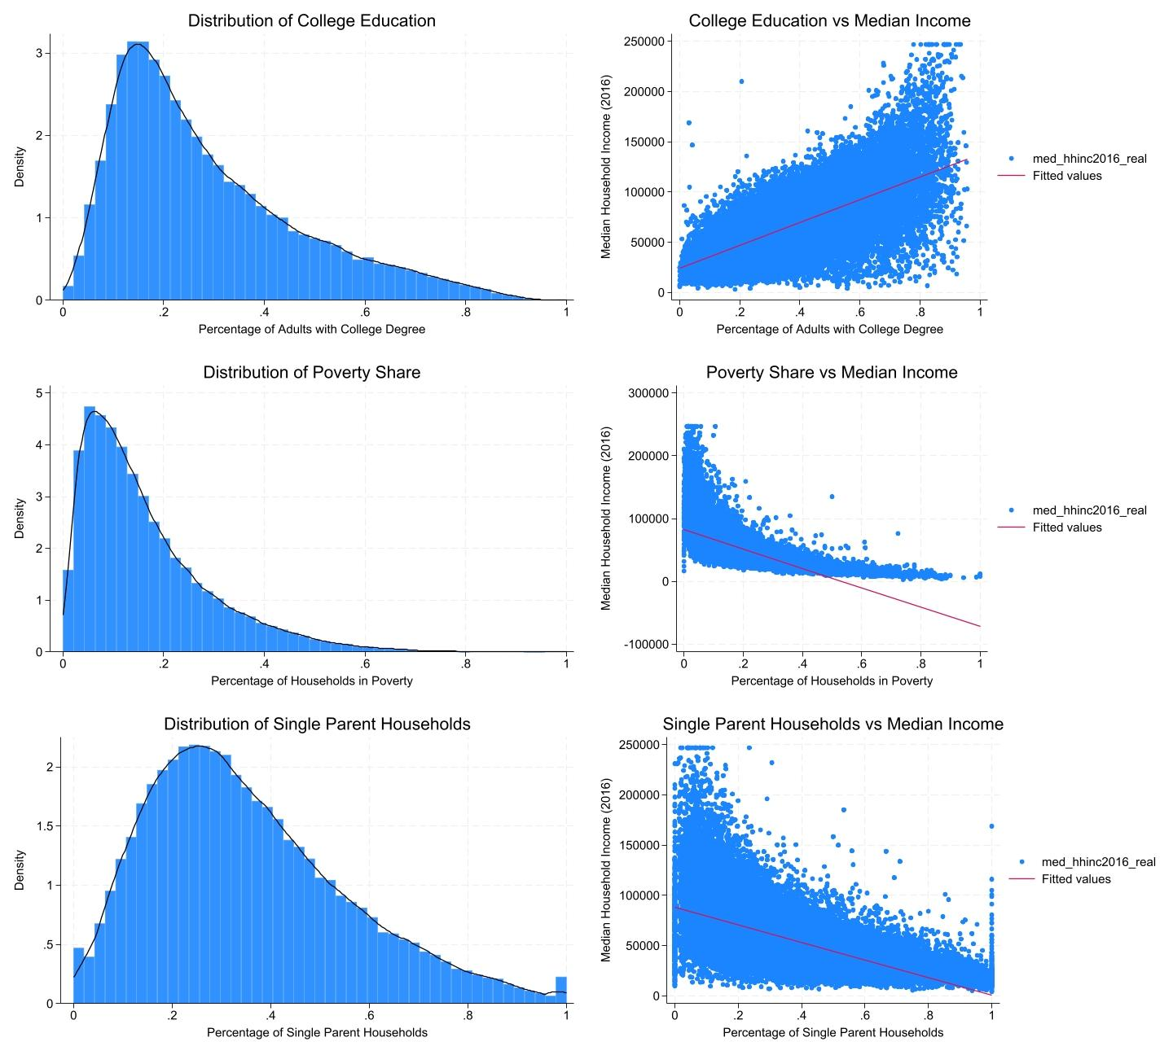

**Figure 7: distribution and correlation of education, poverty, and single-parent households with median household income[4]**

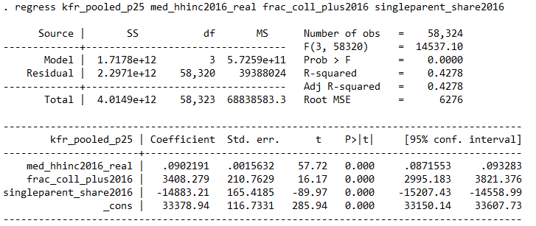

**Table 6: multi regression of median household income, education, and single-parent households on upward mobility**

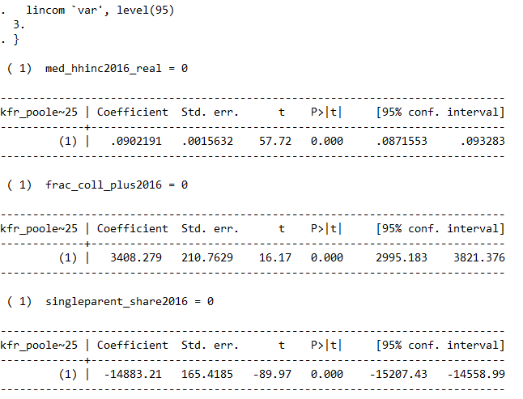

**Table 7: Confidence intervals**

### **Covariate Analysis and Regression Results**

1. College Degree Attainment (frac_coll_plus2016)

Estimated Coefficient: 3408.279

95% Confidence Interval: [2995.183, 3821.376]

Higher rates of college degree attainment are positively correlated with upward mobility, suggesting that communities with a stronger educational foundation tend to promote better economic outcomes for children. A higher proportion of college-educated residents might indicate a supportive environment that values education, creating a culture that encourages skill development and economic advancement. The distribution of education is right-tailed, which is reasonable because it is getting less likely as a tract has more people with college degrees.

1. Single-Parent Households (singleparent_share2016)

Estimated Coefficient: -14880

95% Confidence Interval: [-15200, -14600]

A higher percentage of single-parent households is associated with lower upward mobility. This negative relationship may reflect the additional challenges single-parent families face in providing economic and social stability, which can impact children’s access to resources and support systems conducive to long-term economic success. However, there is a significant peak at the far right, for which a certain number of tracts that nearly or all households are single-parent is even earning a higher median income. This may be because these parents have performed surrogacy and have never married, but still want kids, whereas people might intuitively think that the reason that some parents become single-parent is because of divorcing, which is still the dominant reason for being single parent. The distribution supports this deduction, as the proportion of single parents in a tract increases, the lower the median income that tract will have, showing a negative relationship between these two variables.

1. Median Household Income (med_hhinc2016_real)

Estimated Coefficient: 0.0902

95% Confidence Interval: [0.087, 0.093]

This positive coefficient suggests that higher median household income is associated with increased upward mobility. This relationship could stem from greater household income providing better resources, stability, and educational opportunities for children, which enhances their future economic prospects. This should be one of the most intuitive factors influencing upward mobility.

### **Hypothesis and Correlational Evidence**

Hypothesis: In Philadelphia County, economic opportunity (upward mobility) for children is strongly influenced by socioeconomic stability and educational attainment. Higher household income and greater educational attainment create a supportive environment that fosters upward mobility by enhancing access to resources, networks, and opportunities. Single-parent households, conversely, may experience resource constraints, which can limit access to these same opportunities.

This hypothesis is supported by the statistically significant regression coefficients, which provide correlational evidence linking these covariates to upward mobility. However, it’s important to note that these findings are correlational and do not imply causation. While these factors correlate with upward mobility, additional causal research (e.g., longitudinal studies or natural experiments) would be necessary to confirm that changes in these covariates would directly impact economic outcomes.

In summary, the findings suggest that median household income, educational attainment, and family structure (as indicated by single-parent households) are key determinants of upward mobility in Philadelphia County. For policymakers, these insights underscore the importance of economic support for families, investments in education, and targeted support for single-parent households to enhance economic mobility within the community.

**Model Interpretations of the Model Specifications**

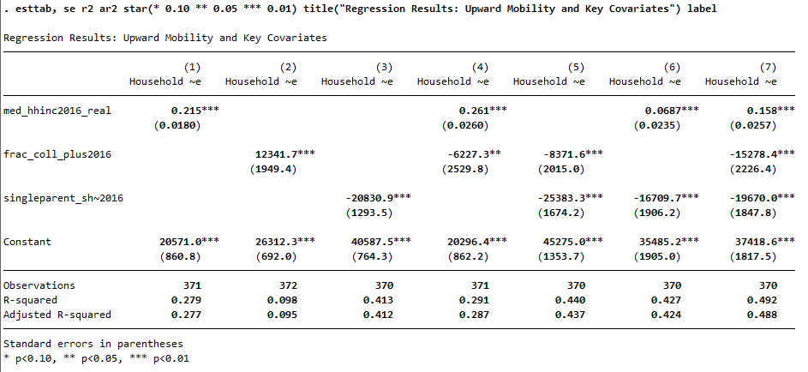

**Table 8: The Regression Results for Upward Mobility**

Table 8 is regressed using the previously mentioned model:

+ + + + )

Model 1 uses median household income as the only explanatory variable. The coefficient result is 0.215 and it is significant at a 1% level. This means that for every $1,000 increase in median household income, upward mobility increases by 0.215 percentage points. The R-squared is 0.279, so median household income alone explains 27.9% of the variation in upward mobility.

Model 2 includes the fraction with a college degree attainment. The coefficient is 12,341.7 and is significant at a 1% level. This means that a one percentage point increase in the fraction of adults with a college degree is associated with a $123.42 increase in upward mobility. The R-squared: is 0.098 so education alone explains only 9.8% of the variation in upward mobility.

Model 3 includes single-parent household share. The coefficient is -20,830.9 and is significant at a 1% level. This means that a one percentage point increase in single-parent households is associated with a $208.31 decrease in upward mobility. The R-squared: is 0.413, suggesting that family structure explains 41.3% of the variation in upward mobility.

Model 4 includes median household income and college degree attainment. Both variables are significant, but the coefficient for college degree attainment is negative (-6,227.3). The R-squared increases slightly to 0.291, so there might be some interaction between these variables.

Model 5 includes college degree attainment and single-parent households. Both variables are significant with negative coefficients. R-squared increases to 0.440, indicating improved explanatory power.

Model 6 includes median household income and single-parent households. Both variables are significant, with single-parent households having a strong negative effect. The R-squared is 0.427, similar to Model 5.

Model 7 includes all the explanatory variables. All the variables remain significant, with college degree attainment and single-parent households showing strong negative effects. We observe the highest R-squared of 0.492, which indicates that the model with all the explanatory variables explains 49.2% of the variation in upward mobility.

Key Findings:

Single-parent household share consistently shows the strongest negative relationship with upward mobility across all models. Median household income has a positive relationship with upward mobility, but its effect is reduced when controlling for other factors. The fraction of adults with college degrees shows a complex relationship, positive when considered alone but negative when controlling for other factors. Model 7 explains nearly half of the variation in upward mobility, suggesting these factors are important but not exhaustive in explaining economic mobility.

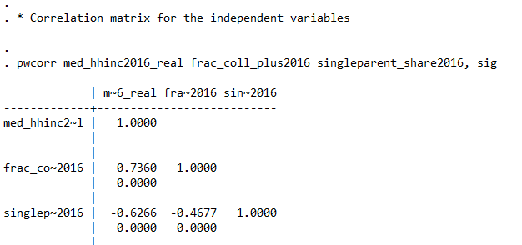

**Table 9: Pairwise correlation results**

The pairwise correlation results seen in Table 9 provide additional insights that complement our results Table 9 shows that the correlation coefficient between household income and college degree attainment is 0.7360 (significant at a 1% level). This means that there is indeed a strong positive relationship between median household income and the fraction of adults with a college degree attainment. The correlation coefficient between household income and the share of single-parent households is -0.6266 indicating a strong negative relationship between the two. The relationship between college degree attainment and the share of single-parent households is -0.4677 so there is a moderate negative relationship between the fraction of adults with a college degree and the share of single-parent households.

However, it's important to note the presence of multicollinearity among our independent variables, as indicated by the pairwise correlations. This interdependence makes it challenging to isolate the individual effects of each factor on upward mobility and suggests that these socioeconomic characteristics are deeply intertwined in Philadelphia's neighborhoods.

Overall, while both income and education are important for upward mobility, family structure—particularly the prevalence of single-parent households—has a profound impact on economic opportunities for children in Philadelphia. Addressing these structural issues may be essential for improving upward mobility and ensuring equitable economic opportunities across different neighborhoods. Therefore, we suggest that policies aimed at supporting family stability, improving overall household income, and addressing the complex role of education would be the most effective in promoting upward mobility in our tract.

Q2

The analysis of upward mobility (*kfr_pooled_p25*) and downward mobility (*kfr_pooled_p75*) outcomes highlights disparities in economic opportunity across income percentiles in our tract as well as the city and state level. Observing the relationship between the 25th and 75th percentile outcomes suggests that economic mobility is limited, especially for lower-income populations. The correlation and linear fit line in the scatter plot show that while there is some alignment between outcomes at different percentiles, those from the 25th percentile background face steeper challenges in achieving higher economic outcomes compared to higher-income counterparts. Previous data points also indicate that economic mobility varies across racial demographics and socioeconomic factors. For instance, variables such as black people’s income at the 100th percentile (*kfr_black_p100*) and white people’s income at the 100th percentile (*kfr_white_p100*) suggest that there are notable disparities in outcomes across racial groups given sufficient other conditions, if not all of them, are similar to each other. These findings can be essential talking points when discussing equitable policy initiatives aimed at reducing these disparities, such as increasing the diversity of the community and monitoring discriminative actions during employment.

While the analysis highlights correlations between economic outcomes and factors such as income percentile and racial demographics, these relationships do not imply causation. The observed associations indicate that certain groups tend to experience different economic mobility levels, but they do not confirm that changing these factors alone would directly lead to improvements in upward mobility. Economic mobility is influenced by a myriad of factors outside and more into the detail of the variables we analyzed. Factors such as job density, education quality, and neighborhood characteristics, although not fully integrated into this analysis, likely play significant roles. A policymaker or journalist could take away that while income and racial demographics are correlated with economic mobility, broader and more holistic policies are necessary to drive substantial improvements. Addressing the complex socioeconomic ecosystem influencing upward mobility would likely involve multi-faceted strategies rather than focusing on a single variable.

The limitations to our analysis are that although it is insightful, multicollinearity limits our ability to make definitive causal inferences. Future research might consider using advanced statistical techniques to address this issue or explore additional factors that influence upward mobility in urban settings. Policies aimed at improving economic outcomes should consider multiple factors simultaneously, including support for family stability, targeted educational interventions, and broader economic development strategies. The negative relationship between college education and upward mobility, when controlling for other factors, warrants further investigation and may indicate a need for more nuanced approaches to educational policy in the context of urban development.

### In conclusion, while these determinants are indicative, we cannot definitively say that adjusting any single factor would causally impact economic mobility without a deeper causal analysis, such as longitudinal studies or experimental designs, to rule out confounding factors.

Thank you for reading!

### 

### 

### 

### References

BambooHR. (n.d.). What Is Upward Mobility? Retrieved from <https://www.bamboohr.com/resources/hr-glossary/upward-mobility>

Chetty, R., Hendren, N., Kline, P., Saez, E., & Turner, N. (2014). Is the United States still a land of opportunity? Recent trends in intergenerational mobility. American Economic Review, 104(5), 141-147.

Chetty, R., J. Friedman, N. Hendren, M. Jones, and S. Porter (2018). The Opportunity Atlas: Mapping the Childhood Roots of Social Mobility. NBER Working Paper No. 25147.

Corcoran, M. (2021). Upward Mobility in Education: The Role of Personal Networks. Social Inclusion, 9(3), 1-11.Chetty, R., J. Friedman, N. Hendren, M. Jones, and S. Porter (2018). The Opportunity Atlas: Mapping the Childhood Roots of Social Mobility. NBER Working Paper No. 25147.

Merriam-Webster. (n.d.). Upward mobility. In Merriam-Webster.com dictionary. Retrieved from https://www.merriam-webster.com/dictionary/upward%20mobility

Remote. (n.d.). What is upward mobility? Retrieved from <https://remote.com/resources/hr-glossary/upward-mobility>

### Appendices

Appendix I: Visualization

Q2. 25th Percentile

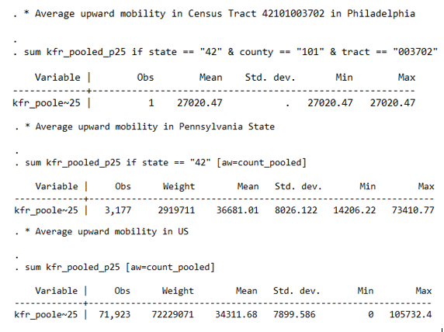

Q3. Standard deviations

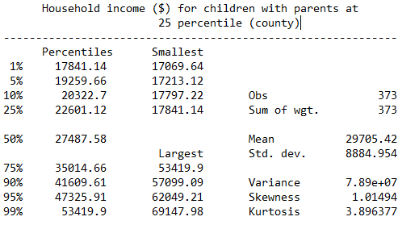

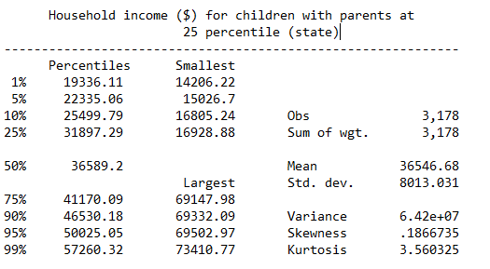

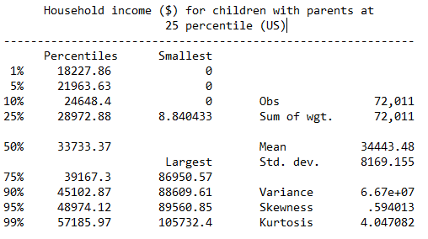

Q4. 75th Percentile

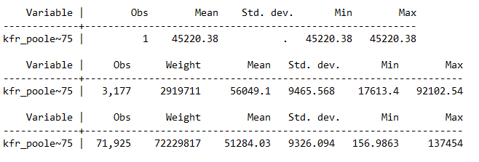

Standard Deviations

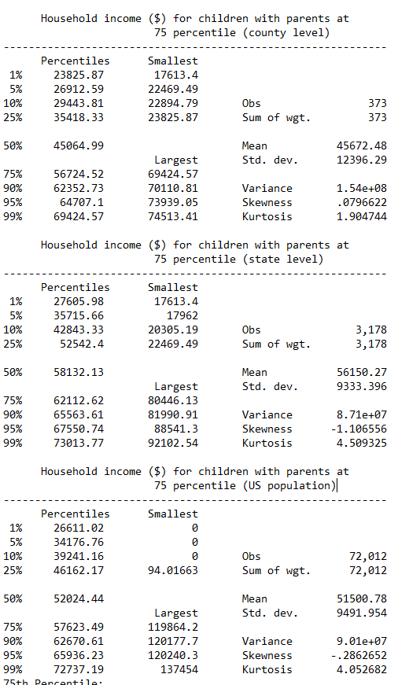

100th Percentile

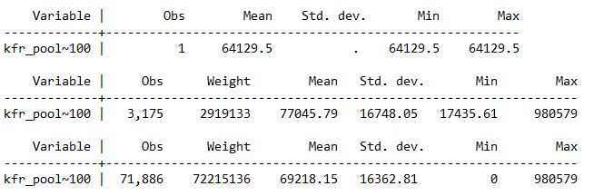

Standard Deviations

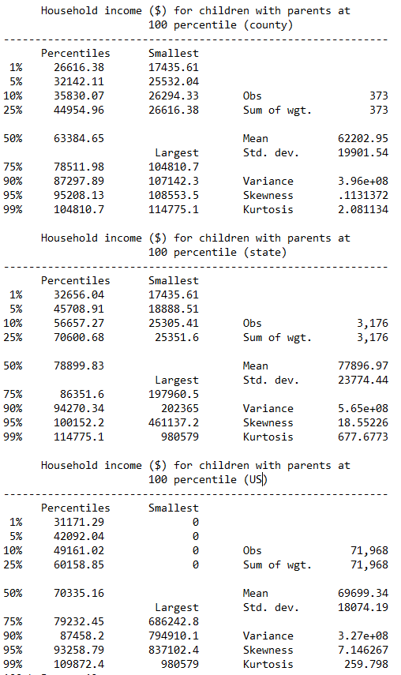

Appendix II: Regression Analysis

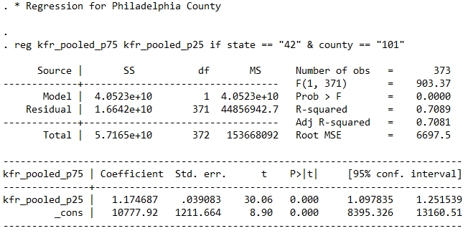

Appendix III: Regression with tract characteristics

Q1. Merging of datasets

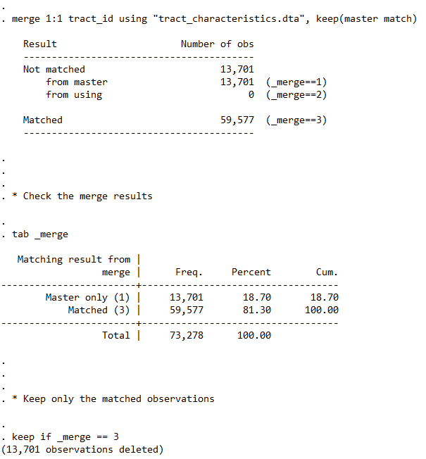

Regressions

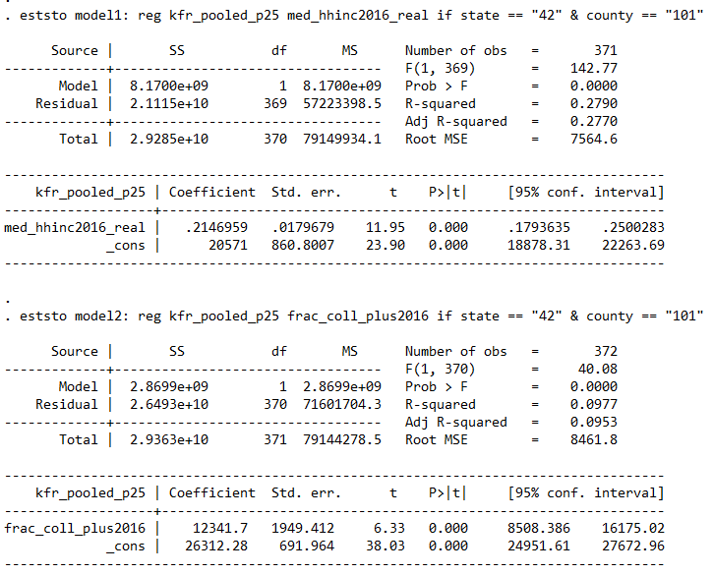

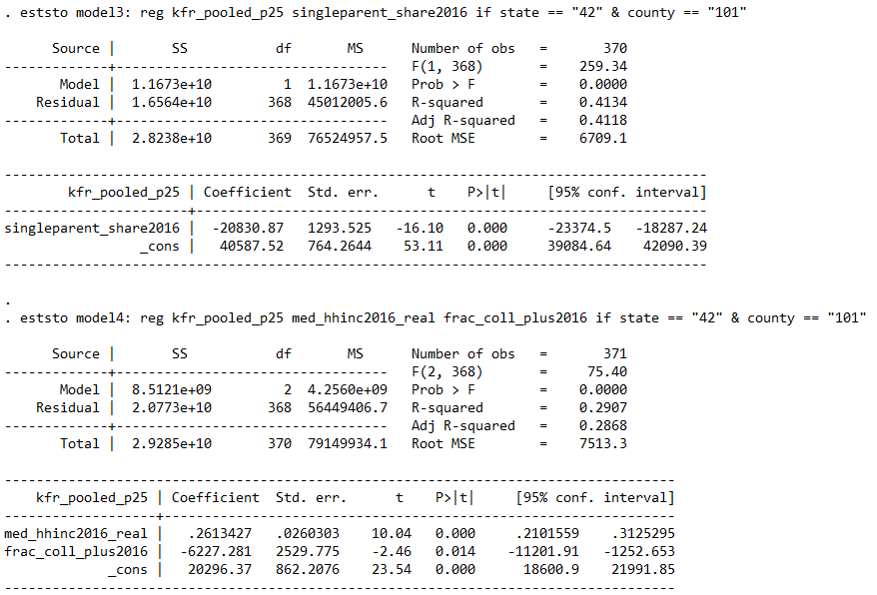

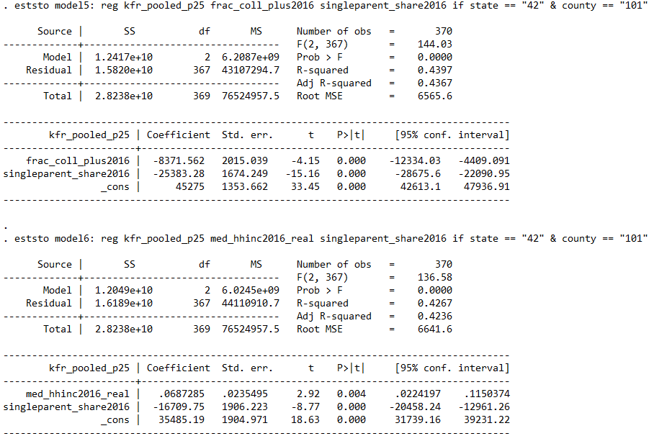

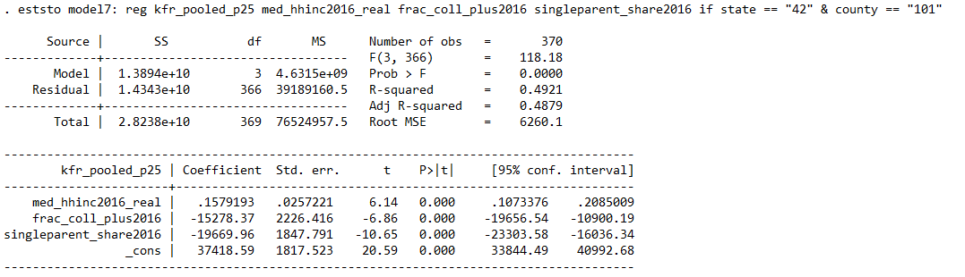

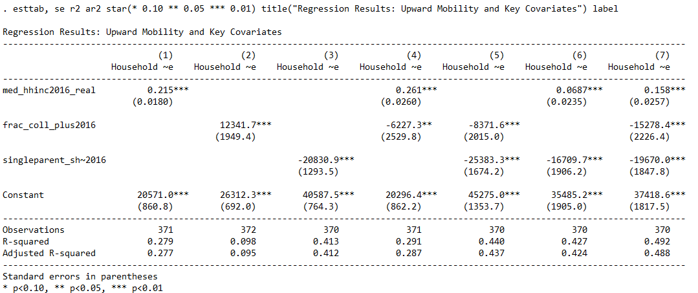

Regression with all variables as predictors of upward mobility



Confidence Interval



Correlation matrix



1. White households have higher incomes than Black households. While household income data is available for Asian households as a whole, there is no breakdown by gender. This lack of data may stem from limitations in data availability or confidentiality concerns. Additionally, some Asian households may choose not to report income by gender for cultural reasons. The Italic numbers are ones that cannot be retrieved at the tract level, so we use the city level number instead.
2. Notes: *kfr_p~25, 75* or *100* is the income for children with parents at the 25th, 75th, and 100th percentile respectively. Source: summarized by authors.
3. For the tract summary, the mean is unweighted, but for the state and country the means are weighted.
4. Note that these graphs test the correlations between variables that will later be used as independent variables to derive correlation with upward mobility as dependent variable. The purpose of showing these is that the independent variables may be interrelated in a statistically significant way, suggesting that the reasons affecting upward mobility is a multi-dimensioned.